Monte Sano Makos
2025
SWIM TEAM HANDBOOK

Monte Sano Makos SWIM TEAM HANDBOOK

WELCOME!

Whether you're returning for another season or joining us for the first time, we are glad to have you as part of the Monte Sano Makos Swim and Dive family. We look forward to a great season of making summer memories.
This handbook is intended to give you the key information you will need to participate. If you have any questions or need clarification along the way, feel free to reach out—we are happy to help.
Jeanette Baumgartner (Rep) - JeanetteB72@yahoo.com 256-684-0444
Monique Williams – mlebeauwilliams@gmail.com
Whitney Harrison – Wabharrison@gmail.com
Michelle Whetstone (Dive)- mwhetstone5@gmail.com

Virginia Navarro (Mako Café) – ginny.navarro75@gmail.coms
Brandi and Scott Copeland (Mako Café) – brandicagle@gmail.com

2025 Coaches
Max Baumgartner
JP Pace
Owen Guerin
Carter Proud
Stuart Morgan
Alec Husky
Will Worthy
Waring Cantey
Lilly Williams
Molly Masterson Lily Cantey
Jenny Baumgartner Emma Mauldin
Addison Whetstone Winnie Pace
Henley Maxey
Ava Leigh Greene
Sara Stoddard
Don Masterson

Registration and Fees
Big News, Makos! Online Registration is Coming!
We’re thrilled to announce that this year’s registration will be online—making it easier than ever to get your swimmer ready for the season! The online process will include all necessary forms, including concussion and waiver forms, and will be available soon.
To jump in and start swimming, you must complete all required forms:
- Registration Form
- Concussion Form
- Parent & Swimmer Agreement
Fees:
- $110 for the first swimmer
- $90 for each additional swimmer in the family
- Mini Makos: $90
All fees are non-refundable and must be paid before a swimmer can participate.
Good to know: If you’ve already paid for a full summer permit, your swim team dues are waived!

TEAM PICTURES
We’re excited to announce that Keri Scogin will once again be capturing our Monte Sano Swim Team pictures this year—so get ready to bring those big smiles and team spirit!
Team Picture Day is Friday, June 13th at 9:15 AM
- Individual and Senior photos will begin promptly at 9:30 AM
- Team photo and senior photos will follow right after

We would love for all Makos to wear their team suit for pictures to show off our team pride and unity!
Seniors – this is your big moment! We must have all senior swimmers present. Senior pictures for banners will be taken during this session, and those banners will be displayed proudly at the pool all season long.
Photo information packets will be sent in advance. Payment is due on picture day if you plan to order individual photos or a banner.

COMMUNICATIONS

To stay up to date throughout the season, we will be sharing important news and updates in two main places:
- Monte Sano Makos Facebook Page – Be sure to join our team Facebook page if you haven’t already! This is a key hub for announcements, reminders, and event info. Just search for the page and request to join.
- Remind Me App – For quick updates, especially about weather-related cancellations, we’ll be using the Remind Me app.
To sign up, simply text @2025monte to 81010 and you will start receiving notifications straight to your phone.

Meet Absences:
If your swimmer is unable to attend a meet, you must fill out the Google Form sent by Greg Wright on the Monday before the meet. This is extremely important for organizing events and relays!

Coach Communication:
You can always get in touch with our coaches by speaking with them before or after practice
Please do not interrupt coaches during practice, as it takes away from our swimmers' instructional time. Also, we ask that parents remain off the pool deck during practice so coaches can stay focused on the swimmers.

SWIMSUITS, CAPS AND SHIRTS (IMPORTANT)

You can purchase your Monte Sano swimsuit at Running Lane located at 2407 Memorial Parkway SW Unit 1, Huntsville, AL 35801. The phone number for Running Lane is 256-696-6122. A team suit is not required, but purchasing it is one way that we can show team spirit, and it creates an exciting atmosphere at the meets as we cheer on our team. Please keep in mind that a suit will not last for long if it is worn to the pool frequently, so please consider using other suits for practices and saving the team suit for use in meets. All swim team members are required to wear a team swim cap during the meets
Running Lane
2407 Memorial Pkwy SW Ste 1 35801
Girls solid royal TYR dura-fast elite
Boys Chroma TYR dura-fast elite
The older girls have requested to wear Jolyn suits this year. Jolyn suits are made for older girls. The 15-17, 13-14, and 11-12 girls will all wear the Blueberry Brandon Jolyn suit unless they choose to wear the TYR dra-fast. I have attached the link for you to purchase your Jolyn suits from Jolyn.
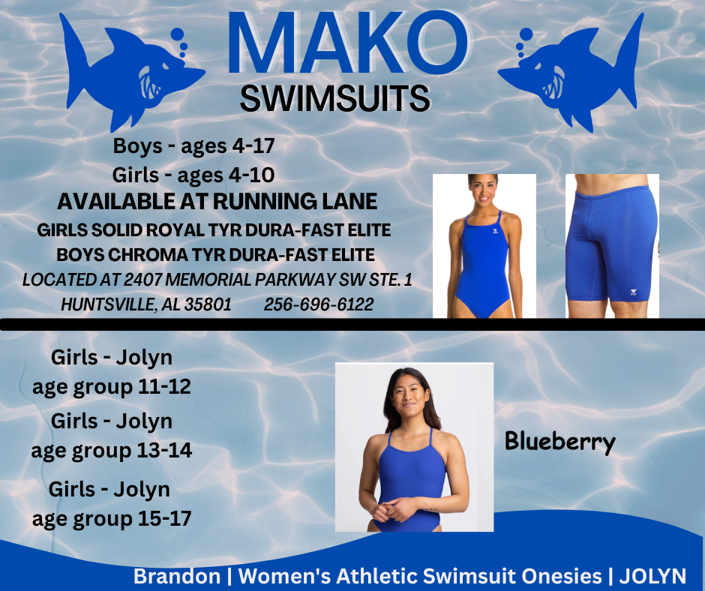

Brandon | Women's Athletic Swimsuit Onesies | JOLYN

11-12 Girls – Brandon Blueberry
13-14 Girls – Brandon Blueberry
15-17 Girls - Brandon Blueberry

Mako Swag
We are excited to offer a variety of Monte Sano Makos gear this season so you can show off your team pride in style!
- Team T-shirts will be available for purchase the first official week of practice - $25 adults $20 kids
- We will also have car magnets available for $10
- An online team store will be launching soon, where you can order hoodies, hats, and other great gear—stay tuned for the link!
- Silicone team swim caps (one size fits all) will be available for $25. If your swimmer has long hair, we highly recommend a silicone cap—they’re more comfortable and can help prevent tears before the race starts.

Practice Schedule
Attendance at practice is highly encouraged and is a prerequisite for competing in main events during swim meets. If you have a year-round swimmer, Coach Stoddard would like your child to swim at least two practices a week. Remember, this is SUMMER FUN, and we want your swimmers to enjoy time with friends and make lasting memories. It is at practice where swimmers receive the instruction necessary to become proficient and strong swimmers. Our younger swimmers are especially inspired when the older swimmers model good sportsmanship and leadership during practice.

Practices are offered on the following schedule, with weekday morning practices beginning once school ends for the summer:

 | Mon | Tues | Wed | Thurs | Fri
9am-10am | 6 and under  Boys (1 lane) | 6 and under  Boys (1 lane) | 6 and under  Boys (1 lane) | 9 am SWIM CLINIC  Fun Day  10-11 | 6 and under  Boys (1 lane)
 | 8 and under Boys (2 lanes) | 8 and under Boys (2 lanes) | 8 and under Boys (2 lanes) |  | 8 and under Boys (2 lanes)
 | 8 and under Girls (2 lanes) | 8 and under Girls (2 lanes) | 8 and under Girls (2 lanes) |  | 8 and under Girls (2 lanes)
 | 9-10 Girls  (2 lanes) | 9-10 Girls  (2 lanes) | 9-10 Girls  (2 lanes) |  | 9-10 Girls  (2 lanes)
10am-11am | 6 and under  Girls (1 lane) | 6 and under  Girls (1 lane) | 6 and under  Girls (1 lane) | Awards at 11 | 6 and under  Girls (1 lane)
 | 9 and 10 Boys (2 lanes) | 9 and 10 Boys (2 lanes) | 9 and 10 Boys (2 lanes) |  | 9 and 10 Boys (2 lanes)
 | 11-12 Girls  (2 lanes) | 11-12 Girls  (2 lanes) | 11-12 Girls  (2 lanes) |  | 11-12 Girls  (2 lanes)
 | 11-12 Boys  (2 lanes) | 11-12 Boys  (2 lanes) | 11-12 Boys  (2 lanes) |  | 11-12 Boys  (2 lanes)
11am-12 | 13 and 14 | 13 and 14 | 13 and 14 |  | 13 and 14
 | 15 and 17 | 15 and 17 | 15 and 17 |  | 15 and 17

Practice Schedule: (some Thursdays will have special swim clinics at 9am – will be announced soon)
Mini Mako’s – 10:45 – 11:15 (Mon, Tues, Wed, Friday) This is subject to change depending on the number of Mini Makos we have.

Regular Season MeetS

June 4 | Monte Sano vs Lily Flagg (HOME)
June 11 | Monte Sano vs Whitesburg (HOME)
June 18 | Monte Sano vs Greenwyche (AWAY)
June 21 | Candy Meet
June 25 | Monte Sano vs Jones Valley (AWAY)
July 2 | Monte Sano vs Blossomwood (HOME)
July 9 | Pasta Dinner at the pool
July 10-13 | City Meet
Our swim team season consists of five dual swim meets, split between three home meets and two away meets as described in the table to the right. Directions will be posted on the Makos Swim Team Facebook page a few days in advance. All five meets will be held on Wednesday evenings, weather permitting. Warm-ups for the home team begin at 5:00 pm and warm-ups for the visiting team begin at 5:30 pm. Swimmers should plan to be at the pool at least 30 minutes before our team's designated warm-up time:

Costumes at Meets
One of the most beloved Monte Sano Makos traditions is our weekly themed costumes at swim meets—and we’re keeping the fun going this season! Our swimmers train hard, but meet day is when we let loose, get creative, and have a blast with friends old and new. Dressing up in themed costumes is a great way to kick off each meet, bring the team together, and show off our Mako spirit! Swimmers and coaches love this tradition, and we can’t wait to see the awesome outfits you all come up with this year. If your swimmer wants to join the fun (and we hope they do!), please arrive in costume at least 30 minutes before warm-ups.
So go all out, get creative, and let’s make this the most spirited season yet!
Monte Sano vs Lily Flagg (HOME) | MAKO PROUD – Wear all blue, Rock your best shark-inspired gear, or even dress like your favorite coach
Monte Sano vs Whitesburg (HOME) | Prom night!! (Wear your corsages and raid your parents closet for their outdated prom attire)
Monte Sano vs Greenwyche (AWAY) | Get ready to wrangle up some gators and show off your wild west spirit! For the Greenwyche meet, we’re going full Western.
Home Monte Sano vs Jones Valley (AWAY) | Pajama night - It’s time to get cozy and show off your comfiest, cutest, and most creative pajamas at our next meet! For this theme, we are coming in full-on relaxation mode. Whether you rock a favorite onesie, classic flannel PJs, or a quirky sleep mask—this is your chance to be comfy and show off your team spirit in style!
Monte Sano vs Blossomwood (HOME) | SUPERHERO - SENIOR NIGHT It’s time to celebrate our incredible 2025 Seniors with a Superhero Theme for Senior Night! These swimmers have been our champions throughout the years, and now it’s time to give them the superhero send-off they deserve!

Special Meets
We’re thrilled to announce that 2026 marks the Monte Sano Makos' 60th anniversary season—a major milestone in our team’s history! To give this celebration the spotlight it deserves, we’ve made the decision to postpone the Stoddard Invitational until 2026. This will allow us to go all out for our diamond year and make it truly unforgettable!
In the meantime, don’t miss one of our favorite annual traditions—The Candy Meet, scheduled for June 21st. This fun-filled event is open to all swimmers 12 and under and promises a sweet time for all!
Mako Café
Concession sales are a huge part of what keeps our Monte Sano Makos swim team running strong, and we need your help to make it a success! The Mako Café will be open during our three home meets. We’ll be serving up crowd favorites like hot dogs, hamburgers, grilled chicken, pulled pork, and more!
To keep everything running smoothly, we’ll send out a Sign-Up Genius link about a week before each meet so you can volunteer. Virginia Navarro is heading up the Mako Café this year and will be sharing more details soon. If you have any questions in the meantime, feel free to reach out to her at ginny.navarro75@gmail.com

ALL Mako families are asked to contribute concession items. This request rotates each season and is essential for keeping our stand stocked and successful.
This year’s assignments are:
Last Names A–M:
- Fresh fruit, cut and placed in individual cups with a plastic spoon taped to the side (10 cups)
- One 12-pack of soda (Coke, Sprite, or Dr. Pepper)
Last Names N–Z:
- Baked goods packaged individually in zip-top baggies (10 items)
- One 12-pack of water or diet soda (Diet Coke, Diet Sprite, or Diet Dr. Pepper)
PLEASE DO NOT BRING CAPRI SUNS, LA CROIX, OR OLIPOP. THEY ARE DELICIOUS, BUT THEY DO NOT SELL.

END-OF-SEASON AWARDS CELEBRATION
Mark your calendars! Our End-of-Season Awards Celebration will take place at the pool on July 13th, following the City Meet. It's a time to come together as a team to celebrate the hard work, spirit, and accomplishments of every Mako swimmer and coach who made this season so special!
We’ll be serving giant cookie cakes provided by our amazing Mako parents. This is always one of the most memorable events of the summer—don’t miss the chance to cheer on your teammates and celebrate another fantastic season with the Makos.

PARENT Volunteers

There are many volunteer opportunities during the season. By being a volunteer, you show support for our team and also have fun. Each family is required to work every meet and once at City Meet. We will have a chart posted on the board outside the lifeguards station to show who has worked. We encourage all new families to be a timer during your volunteer season.

Below is an explanation of each volunteer position that we need to fill for every meet:

Referee (USA Swim Qualified)- The Referee is the chief official for each swim meet. He/she is responsible for the conduct of the meets and is the final authority on the interpretation and enforcement of all swimming rules. Prior to the start of each race, the Referee sounds four short whistles to advise the participants to get ready. After an event is announced by the Starter, the Referee sounds one long blast as a signal for swimmers to get into position for the start or to jump feet first into the water for a backstroke event. For Backstroke events, a second long blast is given to bring the swimmers to the wall for the start. When the Referee sees that all the swimmers are ready, he extends his arm pointing towards the starter. At this point, the Starter takes control. This individual must be trained for this position.

Starter - Starts each event with the announcement of the age and stroke and the words "SWIMMERS TAKE YOUR MARK", pauses to make sure that all swimmers are motionless, and then gives an electronic sound or a blast of a whistle. He/She shall be the sole judge of FALSE STARTS and all false starts shall be restarted. This individual must be trained for this position.

Place Judge – The place judges for each meet only judge the main event heats. The judges determine the 1st through 6th place swimmers and handle any disputes about how the swimmers place. Each team provides three place judges per meet.

Stroke and Turn Judge - The judges watch the swimmers and determine if they are properly swimming each stroke. The judges are required to attend an annual Stroke and Turn Clinic. Each team will provide one stroke and turn judge per meet. This individual must be trained for this position.

Scribe - An assistant who works with both Clerks of Course to track and record any deviations from the original swimmer assignments (scratches, substitutions, changes to heat or lane assignments).

Timers - Records the swimmer’s time. Each timer is provided a stopwatch and assigned a lane. All times are recorded. This job gives you the best view of the pool and the swimmers during their races. We encourage all new patents to time during the season.

Head Timer - Organizes and briefs the Lane Timers on their duties prior to the meet and is in charge of the lane timers throughout the meet. The head timer has the authority to remove and replace any lane timer, with the approval of the home meet director. Previous experience required for this position.

Runner - Responsible for obtaining the completed event cards and DQ forms for each race from the timers and judges. The cards and DQ forms are delivered to the scoring table. The job title is very descriptive. Runners should have good tennis shoes that work well on slippery wet surfaces. This job keeps you moving around at the poolside and the time passes quickly.

Scorer - Marks the official time for each swimmer, records the order of finishes and verifies the computer results. Assigned to work for one half of the meet. With this job, you see the race results before anyone else. (Greg Wright)

Round-up- Involves chaperoning a specific age group at the meets and getting those swimmers in the proper order and lined-up to in time for their event. Responsible for distributing time cards to timers before assigned age group race.

Ribbons - Places labels on ribbons; sorts and files ribbons by swimmer. This job requires you to work Thursday morning. Ribbons must be ready by 11AM ribbon ceremony. This position will be assigned by the swim reps.

Mako Café - You may want to volunteer to work in the Mako Café. Monte Sano has the reputation for having the best café/concession stand in town. You will be emailed to sign-up on Sign-Up Genius a week in advance and ALL families are asked to contribute items for resale.

SWIM MEET TIPS for Swimmers and Their Parents
- Swim meets start promptly at 6:00pm and generally last until 9:30-10:00pm. As you leave the meet, please clean your area, whether at our pool or at a visiting pool. Clean-up is everyone’s responsibility.

- If a swim meet is postponed or halted on Wednesday night, the meet will be rescheduled usually at the same location and time on the following night. (Please let the coaches know if you cannot make the rescheduled meet. If you were scheduled to volunteer in some capacity during the meet, you also need to notify the Volunteer Coordinator that you will be unable to assist during the rescheduled meet.

- Swimmers should always be at the appropriate pool at the assigned time each Wednesday afternoon of a meet. Warm-ups for the home team begin at 5:00pm and warm-ups for the visiting team begin at 5:30pm. Swimmers should plan to be at the pool at least 30 minutes before our team’s designated warm-up time.

- Please write your swimmer’s name and age on his or her shoulders in black marker before each meet.

- You may want to bring lawn chairs with you to both the home and away meets. Most pools do not have enough pool furniture to accommodate all the attendees at a typical swim meet.

- Label all of your child(ren)’s swim items.

- Swimmers should sit in the team area to build team unity. This also allows those volunteering at the meet to locate swimmers, thereby making the meet run more efficiently. In particular, younger swimmers need to stay with the other members of their age group so that their group’s Time Card Distributors can ensure that they get to the starting blocks on time.

- Please bear in mind that when we visit other pools, we are their guests, and we should behave accordingly. Likewise, when we have home meets, let’s all try to be polite and gracious hosts. Remember that all of us (swimmers, coaches and parents) are representatives of Monte Sano Swim Team wherever we go.

Things swimmers should bring to meets:
- Sweatshirt, sweatpants or warm jacket -- it gets chilly sitting around in a wet bathing suit.
- At least two towels; perhaps a blanket or extra towel to sit on
- Goggles (helpful to have a spare)
- Team Swim cap
- Flip-flops, Crocs, or water-proof shoes
- Water bottle
- Cards, music, games, book, etc. – meets are long and kids need something to help pass the time
- Money for the snack bar
- Healthy snacks: Power bars, fruit, string cheese, goldfish

SWIMMER BEHAVIOR GUIDELINES
Successful swimmers. . .

- Listen to their coaches
- Work hard at practice
- Attend as many practices as possible
- Always want to improve
- Think of the team first
- Treat their teammates, coaches and opponents with respect

- Ask questions
- Cheer for their teammates at swim meets
- Are motivated from within to work hard
- Are open-minded to new ideas
- Enjoy themselves in all aspects of life

Tips from the Coaches

- Practice – It is strongly recommended that swimmers attend at least one practice daily. Regular attendance is the key to improvement and overall success. It is mandatory that you attend a practice on Monday in order to participate in the next day’s swim meet. The coach prepares the line-up for the swim meet based on Monday’s attendance.

- Weekly meets – Please try to attend every meet. We depend on all of our swimmers each week. It is preferable that you stay for the entire meet to support your team unless you are in the 6 and under age group. If you must leave a swim meet early, please see the coach before you leave to determine if you are needed for a relay team. Remember, if you are unable to attend a meet, please let the coaches know, in writing, as soon as you can.

- City Meet – Encourage all swimmers to represent our team at the City Meet. The meet provides a great opportunity to measure the progress of each swimmer on a larger scale over the season as well.

COACH’S EXPECTATIONS

- Listen, Listen, Listen!!! This means when a coach is speaking, all swimmers must stay quiet and remain courteous at all times.

- Be on time. Swimmers, please arrive at least 15 minutes before practice starts to stretch out and prepare to enter the pool. For example, if practice starts at 9 a.m., arrive at 8:45 a.m. and be ready to swim at 9 a.m.

- Go to practice. In joining this team, you have made a commitment that should not be broken. The coaches understand there are other obligations, such as being involved with a year-round swim team, religious activities, academic requirements, family emergencies, sickness, job commitments, vacations, etc. Swimmers will not be penalized for any of these reasons; however they are encouraged to attend as many practices as possible.

- Respect!!! Swimmers must respect their teammates, other teams, other pools and their coaches. Being disrespectful to anyone is not tolerated! If a swimmer is being disrespectful he or she will be issued a warning. If it continues, further disciplinary action may be required.

- Stay motivated and positive. An excellent attitude leads to excellent swimming. The coaches will do everything to make sure the team remains positive at all times. In addition, coaches expect all swimmers to motivate each other and display leadership to one another.

- Practice good habits only. Habits are contagious, good and bad; therefore the coaches expect only good habits to be displayed. If everyone swims with great technique then there is no room for bad habits. Remember, “Perfect practice makes perfect.”

- Give every practice and meet your all. As coaches, we expect 100% at practice and meets. Giving more than 100% will separate the good swimmers from the awesome swimmers.

- HAVE FUN!!! In order to have fun, you need to fulfill all the expectations previously mentioned. If you come to practice (on time), show respect, stay positive, always give over 100% at practice and meets and swim with good habits, it is guaranteed you will have fun. You will be rewarded with fast times if all of our expectations are met.

Monte Sano
Volunteering

Home Meet (average - 32 volunteers needed)
Referee (USA swim qualified)
1 Clerk of Course - 4
Place Judge – 2
Scribe – 2
Timers – 6
Starter – 1
Stroke and Turn Judge – 2
Head Timer – 1
Runner – 1
Scorer – 1
Round Up
6 and under girls – 2 6 and under boys – 2
8 and under girls – 2 8 and under boys – 2
9/10 girls – 1 9/10 boys – 1
Ribbons - 2

Away Meet (average – 29 needed)
Place Judge – 1
Scribe – 1
Timers - 0
Starter – 1
Stroke and Turn Judge – 2
Scorer – 1
6 and under girls – 2 6 and under boys – 2
8 and under girls – 2 8 and under boys – 2
9/10 girls – 1 9/10 boys – 1
Ribbons - 2

